Student: Gerelmaa Battsetseg

Professor: Mahmud Jiyan Salim

Subject: Open Source technology and Stream mining

04 November 2022

ARTICLE SUMMARY

This article titled as “ARIMA Model – Complete Guide to Time Series Forecasting in Python” which written by [Selva Prabhakaran](https://www.machinelearningplus.com/author/selva86/) in 22th of August, 2021.

Reason why I choose this article is our project about time series data. So this article all related to our group work.

This article all about how to use ARIMA model in forecast a time series data and how to build an optimal ARIMA model from scratch and extend it to Seasonal ARIMA(SARIMA) and SARIMAX models. Also it shows how to build autoarima models in Python.

# **THEORITICAL PART**

A time series is a sequence where a metric is recorded over regular time intervals. Depending on the frequency, a time series can be of yearly (ex: annual budget), quarterly (ex: expenses), monthly (ex: air traffic), weekly (ex: sales qty), daily (ex: weather), hourly (ex: stocks price), minutes (ex: inbound calls in a call canter) and even seconds wise (ex: web traffic).

ARIMA, short for ‘Auto Regressive Integrated Moving Average’ is actually a class of models that ‘explains’ a given time series based on its own past values, that is, its own lags and the lagged forecast errors, so that equation can be used to forecast future values. Any ‘non-seasonal’ time series that exhibits patterns and is not a random white noise can be modeled with ARIMA models. If a time series, has seasonal patterns, then we need to add seasonal terms and it becomes SARIMA. The equation of the Arima model is given as 

There are 3 terms in equation.

**I : Integration :** The value of d, therefore, is the minimum number of differencing needed to make the series stationary. And if the time series is already stationary, then d = 0.

**AR : Auto Regression :** The time series is regressed with its previous values i.e. y(t-1), y(t-2) etc. The order of the lag is denoted as **p.**

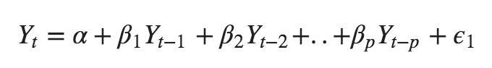

**MA : Moving Average :** The time series is regressed with residuals of the past observations i.e. error **ε**(t-1), error **ε**(t-2) etc. The order of the error lag is denoted as **q.**

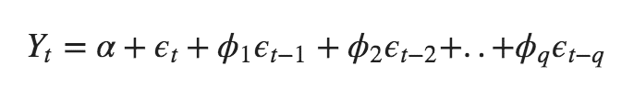

SARIMA **(**Seasonal ARIMA**)** has three more seasonal parameters (P, D, Q). The additional three parameters account for Autoregressive component (P), Differencing component (D) and Moving Average Component (Q) at the seasonal level. where, P, D and Q are SAR, order of seasonal differencing and SMA terms respectively and 'x' is the frequency of the time series. If the model has well defined seasonal patterns, then enforce D=1 for a given frequency ‘x’.

**y’(t) = c + ϕ1* y′(t−1) +⋯ + ϕp*y′(t−p) + θ1*ε(t−1) +⋯ + θq*ε(t−q) + εt**

# CONCLUSION

From this article, I understand the application of ARIMA and SARIMA. Moreover, I saw how to implement those models in python.

Works Cited

<https://www.machinelearningplus.com/time-series/arima-model-time-series-forecasting-python/>

<https://towardsdatascience.com/introduction-to-time-series-forecasting-part-2-arima-models-9f47bf0f476b>